Name: Wade Eckert
Project: Module 4.2: Functional Tests
Course: CSD-380: DevOps
Description: This test plan verifies the core functional requirements of the Todo web application. The test cases evaluate the application's ability to load correctly, display existing tasks, create new tasks, edit existing tasks, and delete tasks while documenting the expected results and any observed issues during testing.
Date: 2026/06/29
To complete the test case plan, fill out the information for Project, Course, Description and Date in the header below.
.
TABLE OF CONTENTS
Test 1 2
Test 2 3
Test 3 4
Test 4 5
Test 5 6

For each test, the developer should: provide a test description, a test objective, the developer name and date tested. For each step, fill out the actions to be taken and describe the expected results, and indicate yes or no for each step depending upon the result. The peer tester should provide their name, date tested, indicate yes or no for each step depending upon the result, and a screenshot (thumbnail) of the result.

Test 1 | Verify Todo Application Loads from Required URL
 | Test Objective: Verifies that users can visit the Todo application through the required URL and that the landing page loads without visible errors. | Developer: Wade Eckert  Date tested: 2026/06/29 | Peer tester: Chanceller Waters  Date tested: 2026/07/04
Step | Action | Expected results: | Developer pass/fail | Tester pass/fail  + Screenshot
1 | Open a web browser and navigate to https://buwebdev.github.io/todo/ | The Todo application loads successfully without visible page errors. | Yes | 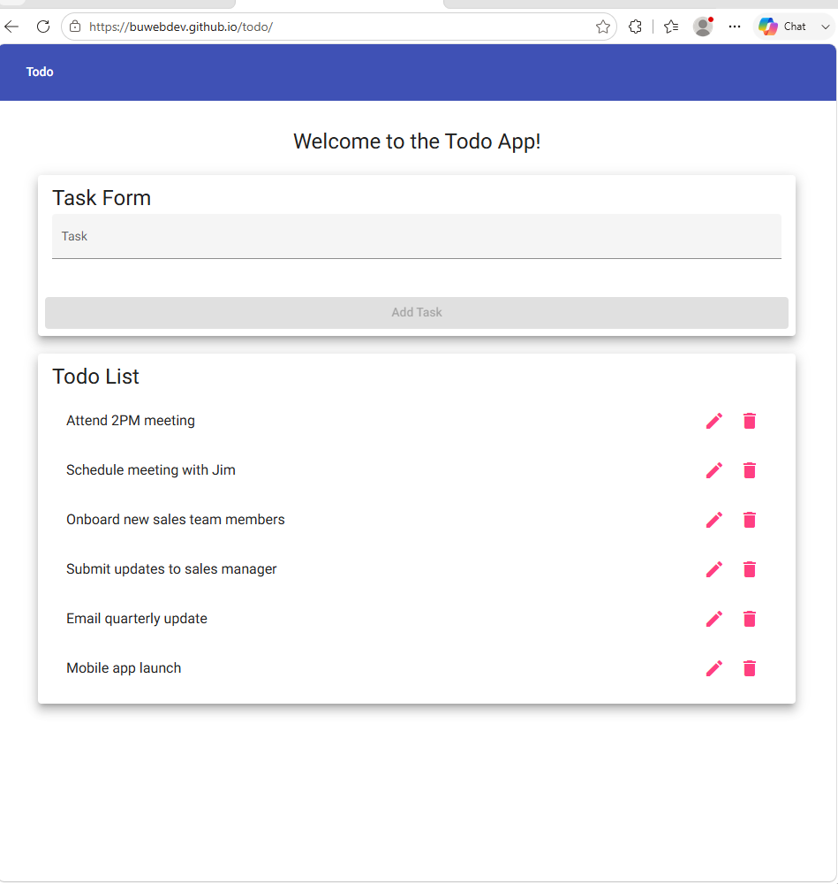
2 | Verify the browser displays the Todo application landing page. | The page displays the blue Todo header, the welcome message, the Task Form, and the Todo List section. | Yes | 
3 | Refresh the browser window. | The Todo application reloads successfully and displays the default landing page content. | Yes | 
Comments | The application loads successfully from the required URL and refreshes without visible errors. Any tasks added, edited, or deleted during the session return to the default list after refreshing the browser, but persistence after refresh is not specifically listed as a requirement in the business requirements document, therefore, this behavior was documented as an observation rather than a test failure.-Wade

Test 2 | Verify Existing Todo Task Items Are Displayed
 | Test Objective: Verifies that users can view the existing todo task items in the Todo List. | Developer: Wade Eckert  Date tested: 2026/06/29 | Peer tester: Chanceller Waters  Date tested: 2026/07/04
Step | Action | Expected results: | Developer pass/fail | Tester pass/fail
1 | Open a web browser and navigate to https://buwebdev.github.io/todo/. | The Todo application landing page loads successfully. | Yes | Yes  
2 | Locate the Todo List section on the page. | The Todo List heading is visible below the Task Form. | Yes | Yes  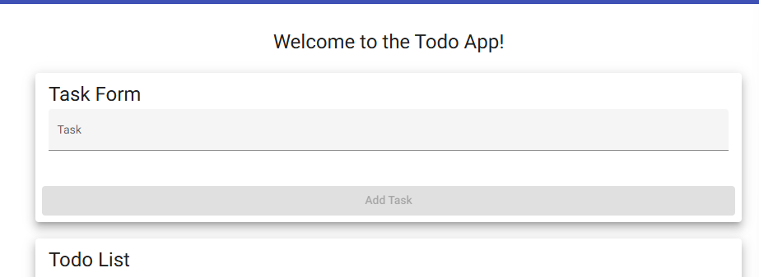
3 | Review the default task items displayed in the Todo List. | The default todo task items are visible and readable. | Yes | Yes  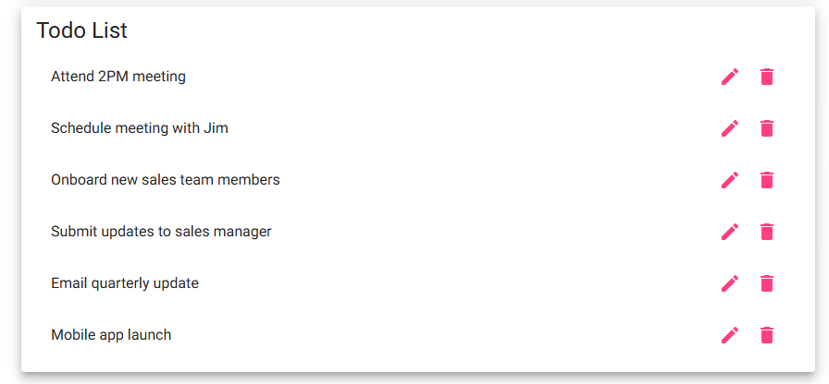
4 | Verify that each listed todo item includes available action icons. | Each todo item displays an edit icon and a delete icon. | Yes | Yes  
Comments | The Todo List displays correctly when the application loads. The default tasks are readable, organized vertically, and each task includes icons for editing and deleting, which supports the application's core task management functionality. -Wade

Test 3 | Verify a User Can Create a New Todo Task Item
 | Test Objective: Verifies that users can create a new todo task item and that the new task appears in the Todo List. | Developer: Wade Eckert  Date tested: 2026/06/29 | Peer tester: Chanceller Waters  Date tested: 2026/07/04
Step | Action | Expected results: | Developer pass/fail | Tester pass/fail
1 | Open a web browser and navigate to https://buwebdev.github.io/todo/. | The Todo application landing page loads successfully with the Task Form and Todo List visible. | Yes | Yes  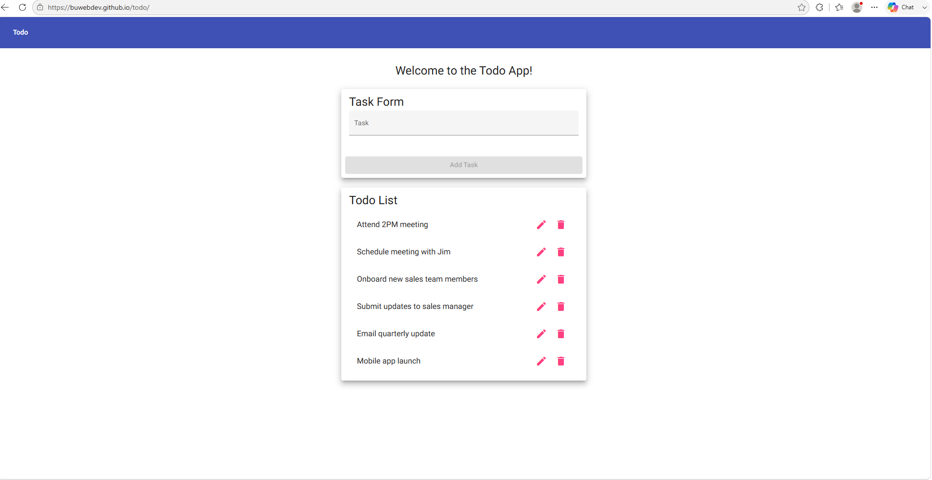
2 | Click inside the Task input field and enter a task name containing at least four characters. | The entered text appears in the Task input field, and once at least four characters have been entered, the Add Task button becomes enabled. | Yes | Yes  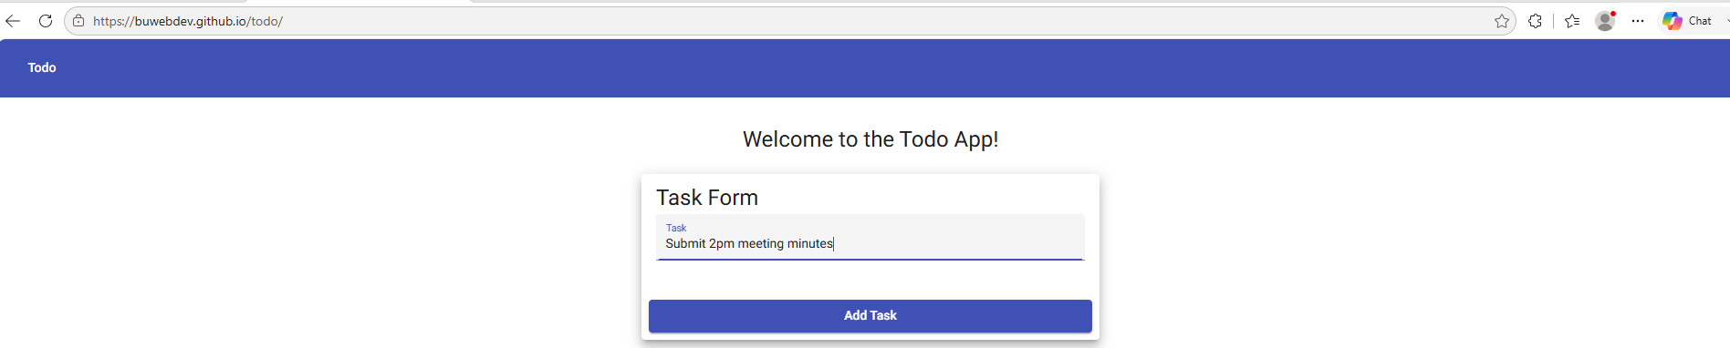
3 | Click the Add Task button. | The new todo item is submitted successfully. | Yes | Yes  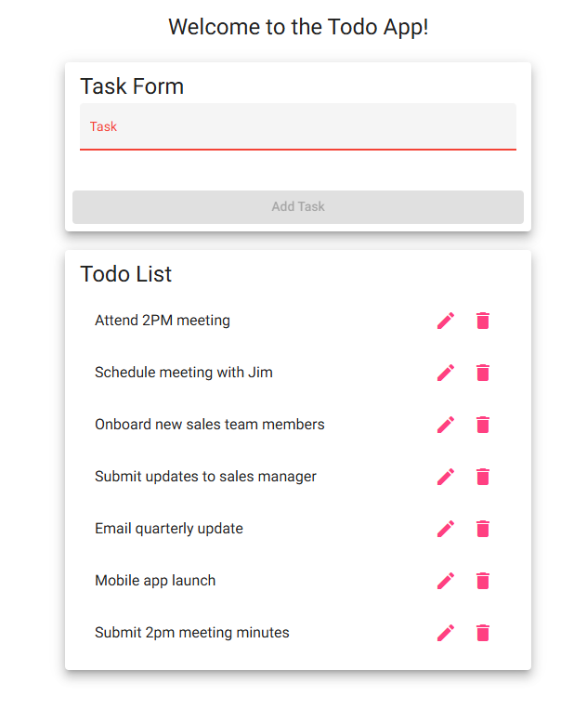
4 | Review the Todo List after submitting the new task. | The newly created task appears at the bottom of the Todo List. | Yes | Yes  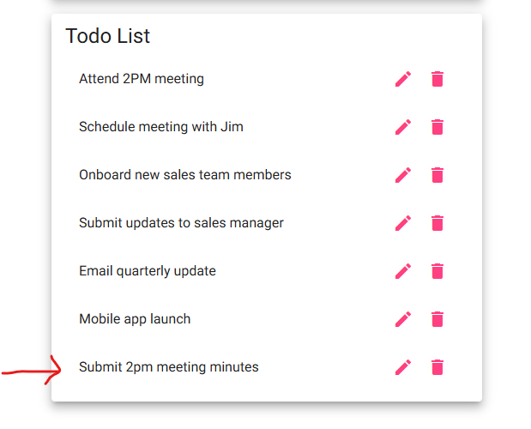
5 | Review the Task input field after the task is added. | The input field clears and the Add Task button becomes disabled again. | Yes | Yes , and red line in task input field appears as stated by dev  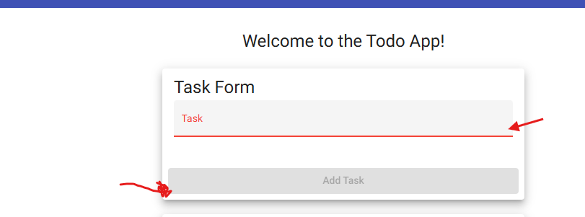
6 | Enter fewer than four characters into the Task input field. | The Add Task button remains disabled, and the task cannot be submitted. | Yes | Yes; add task button remains disabled and red line persists  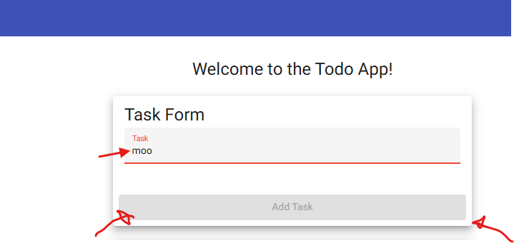
7 | Enter only blank spaces into the Task input field and attempt to add the task. | The application should reject the blank input, the Add Task button should remain disabled (or the task should not be added), and no blank todo item should appear in the Todo List. | No | Program accepts bblank task ( minimum four “”characters” and adds it to last list  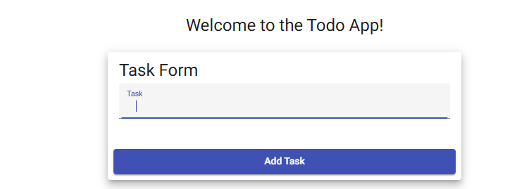  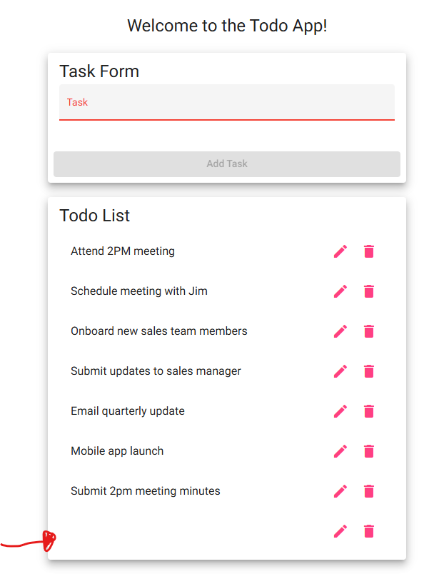
Comments | The application successfully allows a user to create a new todo task item. The new task appears immediately at the bottom of the Todo List, and the input field clears after submission. One visual observation is that the input field displays red styling after submission instead of returning to its original appearance. It was also observed that the application accepts input containing only whitespace characters (e.g. four blank spaces) and creates a blank todo item. This behavior does not match the expected validation for a required text field and should be corrected by trimming whitespace and rejecting blank task entries. -Wade

Test 4 | Verify a User Can Edit an Existing Todo Task Item
 | Test Objective: Verifies that users can edit an existing todo task item and save the updated task without changing its position in the Todo List. | Developer: Wade Eckert  Date tested: 2026/06/29 | Peer tester: Chanceller Waters  Date tested: 2026/07/04
Step | Action | Expected results: | Developer pass/fail | Tester pass/fail
1 | Open a web browser and navigate to https://buwebdev.github.io/todo/. | The Todo application landing page loads successfully with the Todo List visible. | Yes | Yes  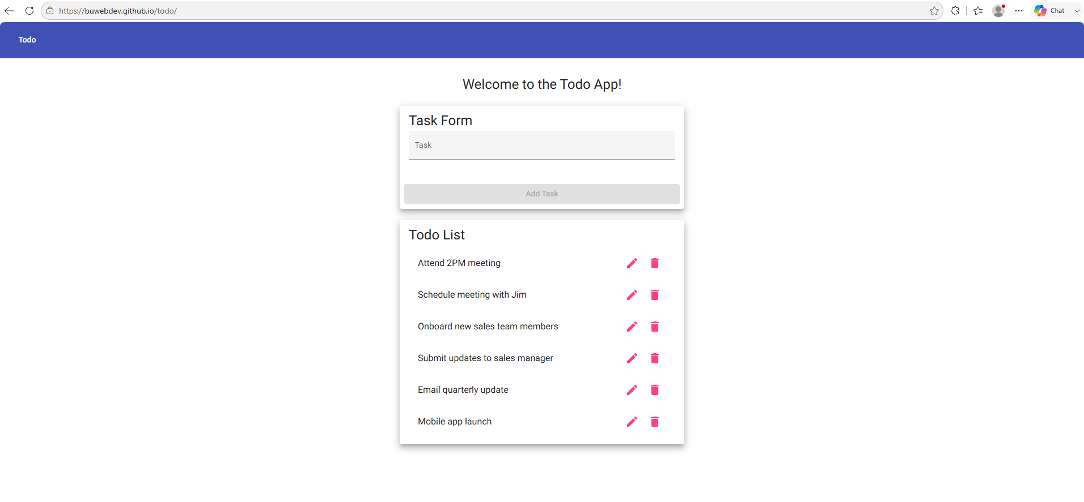
2 | Click the edit icon next to one of the tasks. | The Edit Form opens and displays the selected task text. | Yes | 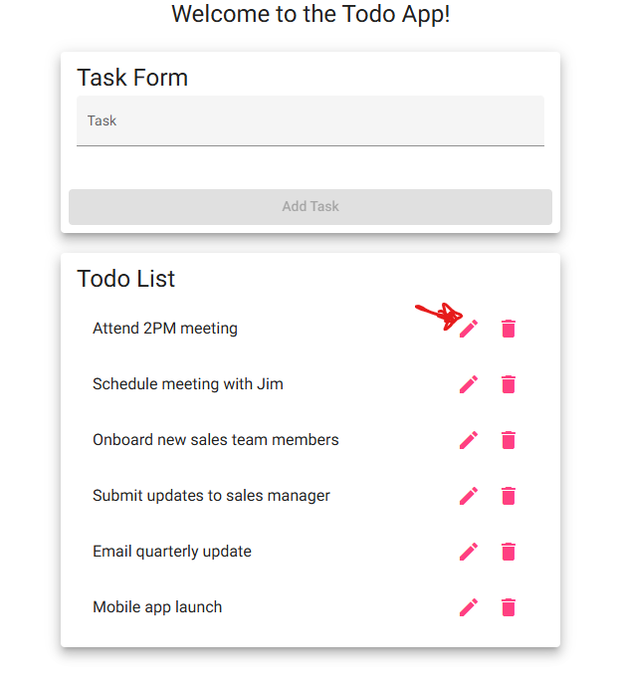  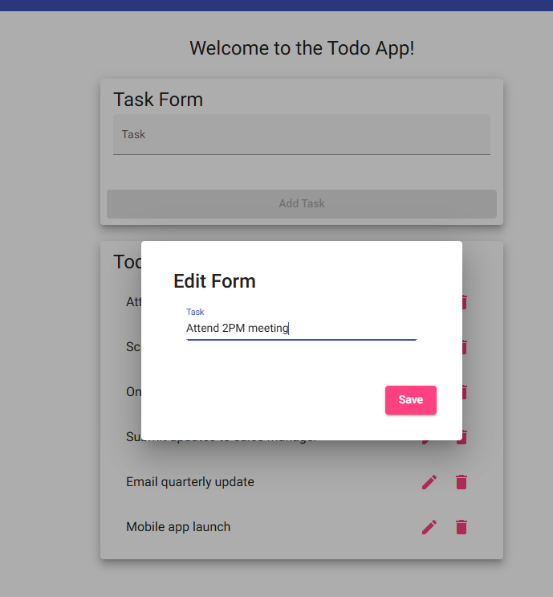
3 | Change the task text to something different. | The updated task text appears in the Edit Form input field. | Yes | 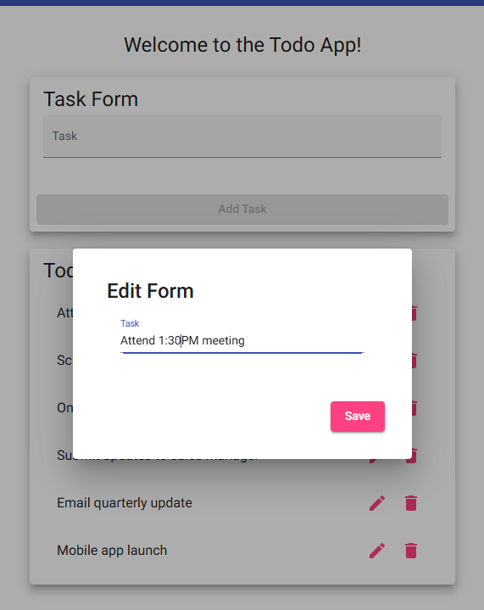
4 | Click the Save button. | The Edit Form closes and the Todo List is displayed again with the edited task. | Yes | 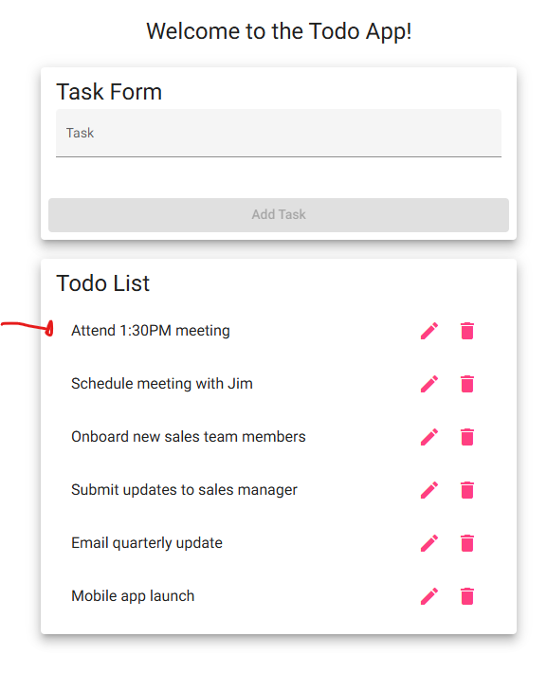
5 | Review the updated task in the Todo List. | The edited task replaces the original task and remains in the same position in the list. | Yes | 
Comments | The application successfully allows a user to edit an existing todo task item. The Edit Form opens correctly, the task text can be changed, and the updated task is saved back to the Todo List without changing the task's position. -Wade

Test 5 | Verify a User Can Delete an Existing Todo Task Item
 | Test Objective: Verifies that users can delete an existing todo task item from the Todo List. | Developer: Wade Eckert  Date tested: 2026/06/29 | Peer tester: Chanceller Waters  Date tested: 2026/07/05
Step | Action | Expected results: | Developer pass/fail | Tester pass/fail
1 | Open a web browser and navigate to https://buwebdev.github.io/todo/. | The Todo application landing page loads successfully with the Todo List visible. | Yes | 
2 | Locate the first task in the Todo List. | The task is visible and includes a delete icon. | Yes | 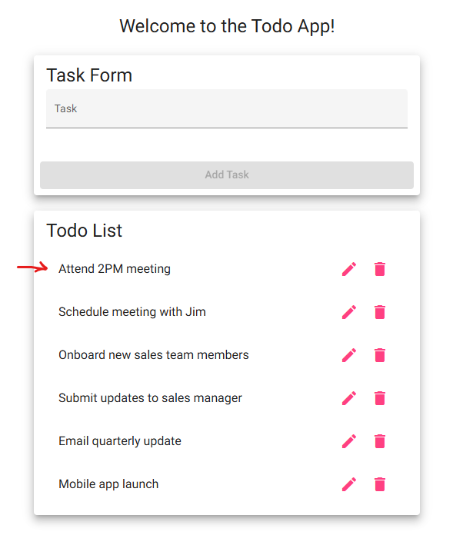
3 | Click the delete icon next to the first task. | The selected task is removed from the Todo List and no longer visible. | Yes | 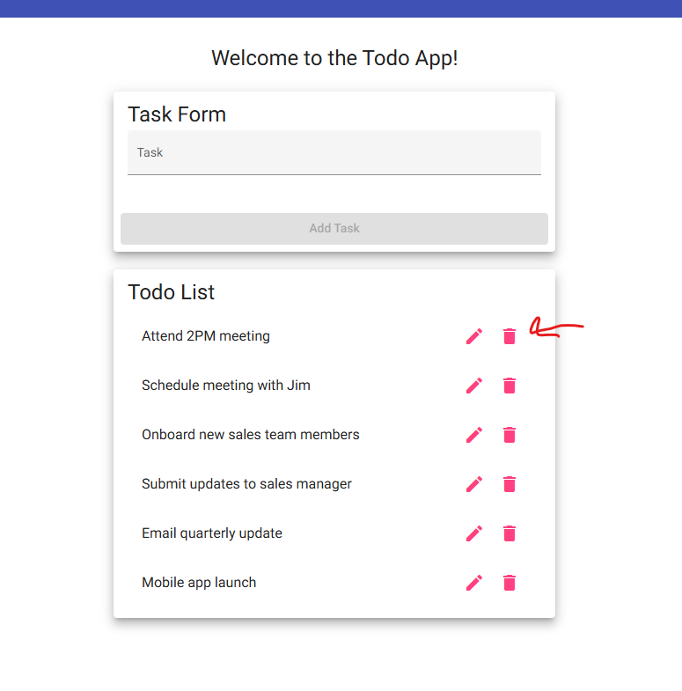  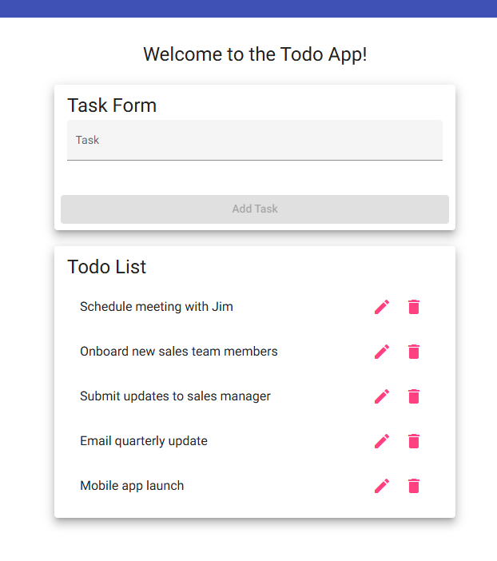
4 | Verify the remaining todo items are still displayed. | The remaining todo items are visible, readable, and remain in the correct order. | Yes | Yes  
Comments | The application successfully allows users to delete todo task items. Selecting the delete icon immediately removes the selected task from the Todo List, while the remaining tasks continue to display correctly and maintain their order. Additional testing confirmed that deleting every task functions as expected. After all tasks are removed, the Todo List heading remains visible and the application continues to operate normally without any visible errors or layout issues. -Wade

